Issue with Importing PowerPoint into Lectora
First, I am unable to see the .pptx extension in file manager. I can locate the PowerPoint by typing in *.pptx

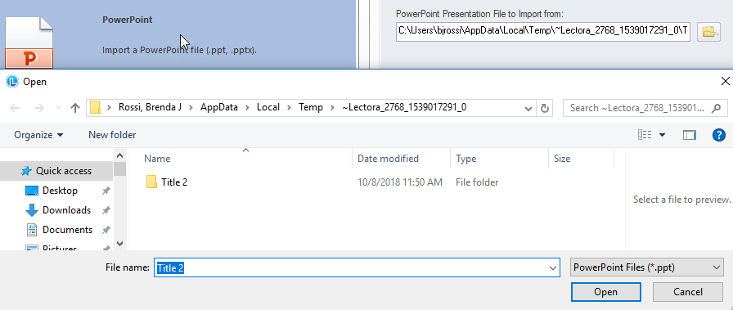
After locating the file using *.pptx. The following error message appears in file manager regarding PowerPoint.

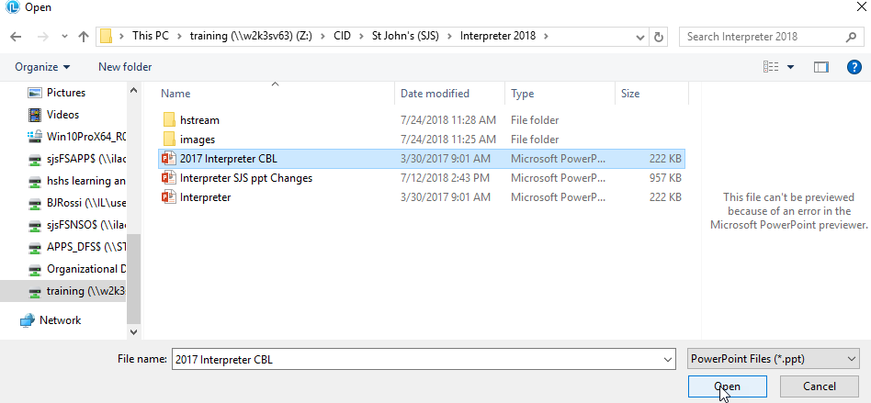
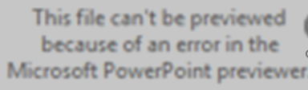

When I click OK to Import the file the following message comes up regarding memory and system resources (IT added more memory to my computer)
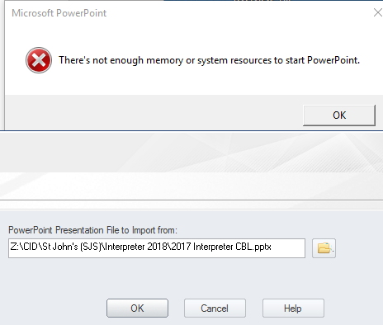
Then the last message comes up that says it does not support the PowerPoint version. We are currently on PowerPoint 16. I sent Trivantis support a PowerPoint that we are trying to import, and they did not have an issue importing it.
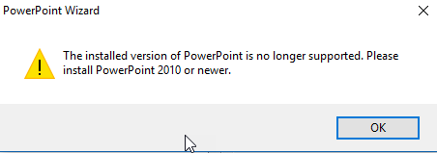
Here is what we have tried so far
- Memory added to computer
- Initiated Trivantis Support Case #169334
- Used various PowerPoint extensions .ppt and .pptx
- Uninstalled version 16 and 17 and reinstalled Version 17

