Scrolling Form Example

About the Attachments
- I’ve included in the Zip my current testing project that has been converted to Lectora 2017 (at home).

Current Setup
- At the Title Level
  - Is this a bad way to do this? I notice that some people have been pasting in the minified jQuery here instead. What are the pros/cons?
  - script uses a link to the latest jQuery on web via the HTML Extension
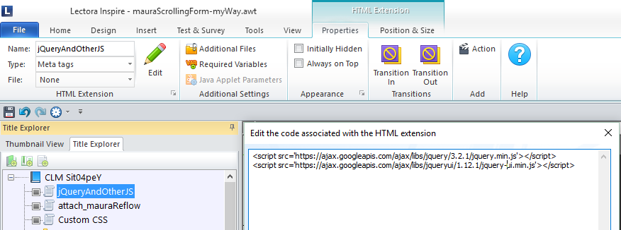
  - another to attach mauraReflow.js
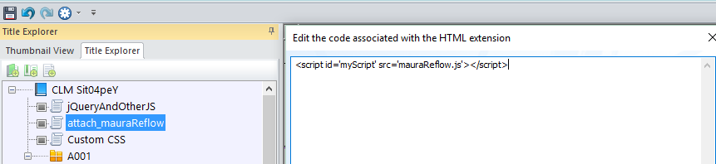
  - another for custom css
- At the Page Level (Scrolling Example) run JS onShow:
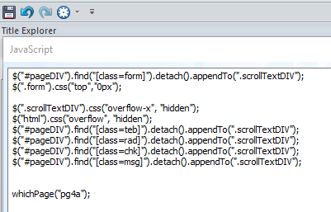
  - Detach the Form (class=form) and append it to my scrollTextDIV (class) which is for a text block called “toScroll” in the Title Explorer and is set for Vertical Scroll
  - Use jQuery to reposition the form within the scrollTextDIV;
  - Use jQuery to set overflow-x to hidden for scrollTextDIV;
  - Find, detach, and append all classes (teb, rad, chk, msg) to scrollTextDIV using jQuery
  - Run whichPage(“pg4a”) to then work through a set of if statements and call up the page specific function for each page. These functions then reposition all of the input and error messages using inelegant JavaScript.
- I’d like to get to the point of looping to do this and have this so far:
- var arrayTEB = [];
$(".teb").each(function() { arrayTEB.push(this.id); });
console.log(arrayTEB);
var numTEB = arrayTEB.length;
console.log("Number of textEntryBoxes = " + numTEB);

- var arrayRAD = [];
$(".rad").each(function() { arrayRAD.push(this.id); });
console.log(arrayRAD);
var numRAD = arrayRAD.length;
console.log("Number of radioButtons = " + numRAD);

- var arrayCHK = [];
$(".chk").each(function() { arrayCHK.push(this.id); });
console.log(arrayCHK);
var numCHK = arrayCHK.length;
console.log("Number of checkBoxes = " + numCHK);

- var totalInputs = arrayTEB.concat(arrayRAD, arrayCHK);
console.log(totalInputs);
var length = totalInputs.length;

Questions

Preview in Browser
- Previewing in either IE or Chrome the JS and jQuery works fine although at the office, for IE, I must: allow scripts > F12 > Choose 10 instead of 11 to get the page to display
  - Why?

Review Link
- I tried to test the project in Review Link last night from home. (I have version 2017 at home, but it has not yet been installed at work). None of the JS/jQuery worked. Is it disallowed? If not, what could be the problem? Is this because I didn’t use the minified code in my HTML Extension?

Publish to HTML
- When I published (from home since I have 2017 there, but not yet at work) and tried to preview it from the dialog box that came up, JS/jQuery were not working properly. Is this because I didn’t use the minified code in my HTML Extension?

