INSTRUCTOR/REPORTER UNABLE TO MANAGE USERS (submitted 8/12/2016 at 4:10p)
Scenario: Employee is set-up in Coursemill with Instructor/Reporter Privileges and granted full User Permissions. When Instructors log in, they do not have ability to Manage Users.
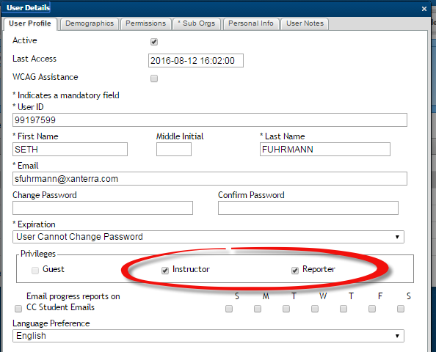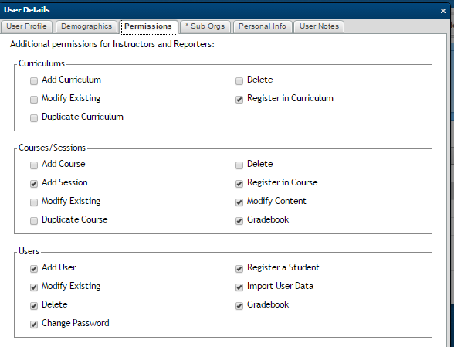
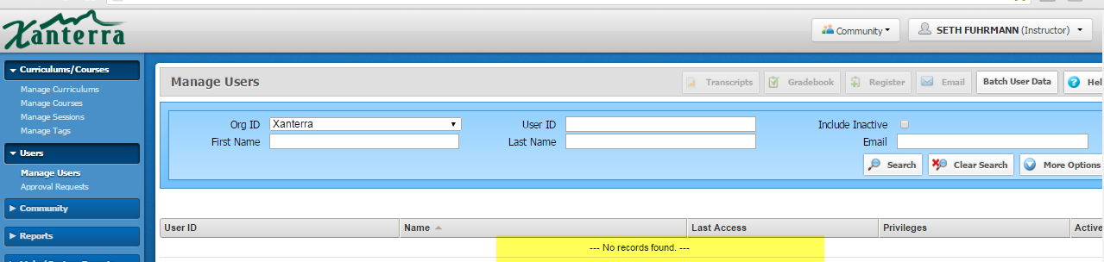

Ricky Rice is an instructor and reporter however, he is not the Instructor assigned to this session (1329). Patricia Young is the Assigned Instructor.
Ricky Rice is not registered in this Course or Session.
