MURA storyboard

# | On Screen | Screen Action | Assessments and Notes
1 | 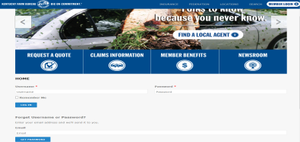  Our website is kyfb.com.  To access the content management system to update page content, press “Esc” and “L” on the keyboard at the same time.  To log in enter your network username and password. Click LOG IN when finished.  Click LOG IN now to go on. | Show kyfb.com site IMG: webpage.png  Provide button made of ESC and L keys. When clicked show IMG: logInScreen.png  Add action to LOG IN button to go to next screen. | What keys need to be pressed to access the content management system?  Ctrl+L  Esc+L  Shift+C  Make answer choices images instead of text.
2 | 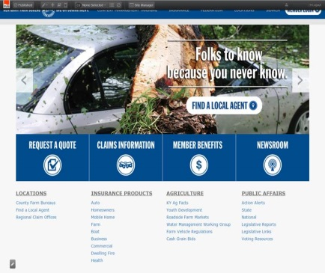  After logging in, you’ll see a black toolbar across the page.  From the toolbar, you can access the dashboard and other site management tools to review, edit and update site content.  Let’s take a closer look at the toolbar. | Show IMG: AfterLogIn_insurance.jpg  Add text as pop-up.
3 | 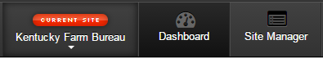  In the toolbar you have navigational buttons that take you to view current site statistics, dashboard, and site manager.  Click the Dashboard button  Click the Site Manager button  Now that you’ve viewed the toolbars, let’s see how you search for content. | Show IMG: toolbar_up_close.png  Action: Make toolbar buttons clickable. Go to corresponding pages.  Dashboard goes to 3.1  Site Manager goes to 3.2  Show this text: Now that you’ve viewed the toolbars, let’s see how you search for content. After screens 3.1 and 3.2 have been accessed. | If you want to see site statistics and the most popular content, where would you look on the toolbar?  Dashboard  Site Manager  MURA icon
3.1 | 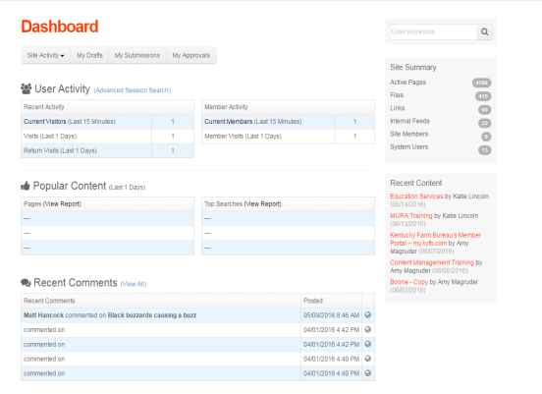  The dashboard gives statistical results of the activity of the webpage. There are two important sections to know about on the dashboard:  Popular Content and Recent Content  Popular Content  This section shows both the top pages that are viewed on the webpage and Top Searches that people look for while visiting.  Recent Content  This section shows the most recent items added to the webpage. | Show IMG: DashboardView.png  Will need to group images with corresponding text. Add actions to buttons to show correct group.  After page is viewed, set action so user returns to screen 3. | Make popular and recent buttons. When clicked these will show a highlighted section on the screen and corresponding text.  Should more be added here about popular content to give example of updating page based on popular searches???
3.2 | 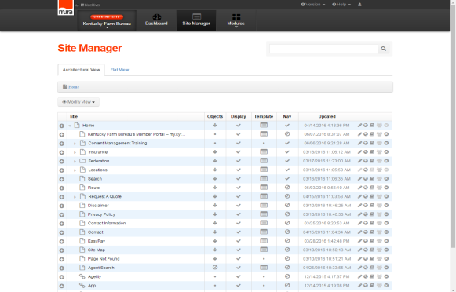  The site manager permits you to search for content. It’s like the folder that structures all the website content, including files, images, and text. There are two views available by using the tabs near the top of the screen:  Architectural View and Flat View  Architectural View  This view is a folder system layout of how the each webpage is designed.  The first folders you will see are the pages you have access to update. Following these will be a list of links and pages on the website/webpages.  Flat View  The Flat View shows the users the most recent updated content. | Will need to group images with corresponding text. Add actions to buttons to show correct group.  After page is viewed, set action so user returns to screen 3.
4 | Searching content  To search for content, click the Site Manager button. 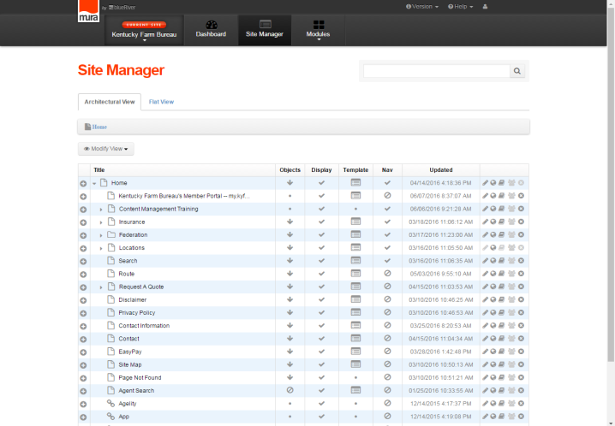From either the architectural view or flat view, type in your search criteria in the top right corner.  To search for most recently updated content, choose the flat view. Select the flat view tab then type: education in the search bar and press enter on your keyboard.  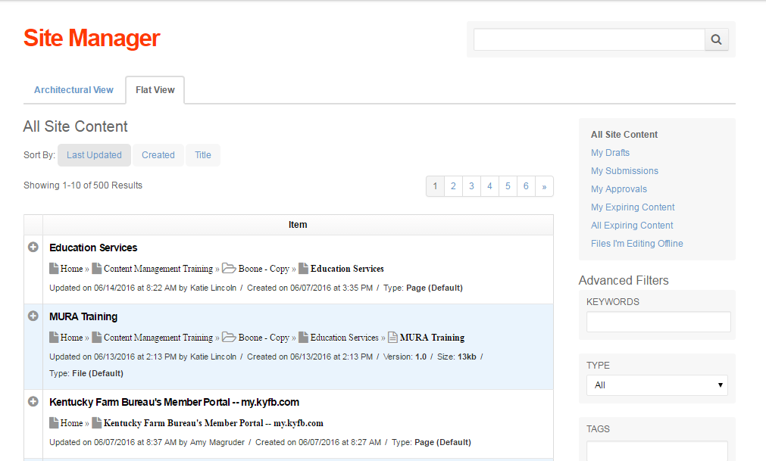  The flat view will return the search results in the last updated order. This can be rearranged by selecting to change the sort to create or title. | IMG: toolbar_up_close.png  Add action to site manager button. Show IMG: SiteManagerSelected.png  Delay arrow that points to search box.  Add an action to the flat view tab. That will hide image and show IMG: SiteManagerFlatView.png  Add an entry field, when entered show Flat View with sorting area highlighted and show the text: The flat view will return the search results in the last updated order. This can be rearranged by selecting to change the sort to create or title.
5 | Editing content  To add new website content, click the Site Manager button on the toolbar.  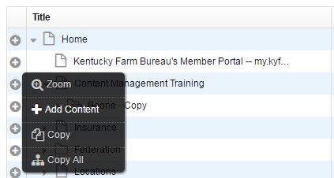  Locate the folder you wish to add your new content to. Place your cursor over the plus sign to the left of the content you wish to update. The Add Content box will appear. Click on Add Content to select your content type. | Show IMG: toolbar_up_close.png  Add action to click site manager button. Show IMG: SiteManagerSelected.png  Add action to show IMG: AddContentBox.png when mouse hovers over plus signs.  Add action to go to next page with Add content is clicked.
6 | 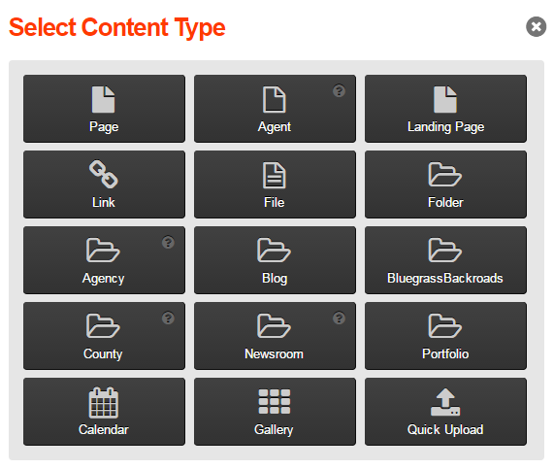  The Select Content Type box will appear. Click on the type of content you are adding to your page. In most cases you will choose File, Page, Link, Agency or County when adding content.  For this example, we’ll add a new page. Select the Page button. | IMG: SelectContentType.png  Add action to go to next page by clicking file.
7 | 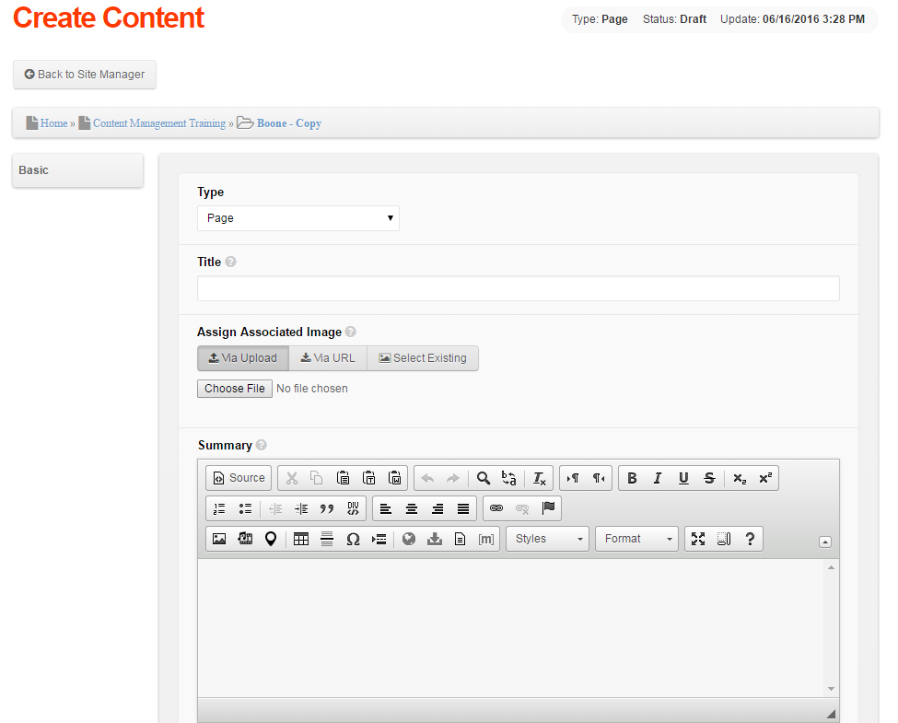To add or edit content, you’ll see the Edit Content Screen.  - Add the title. This will be your page/file header which will make it easy to search and review.  - Create a short descriptive summary to inform the reader what your content is about. You can also choose to pull the first paragraph of your text to insert into the summary. When adding pages, you will have an additional field to create your content. The content box will hold all of the page information that you wish to add.  - The Content box will hold all of the page information. This will be the body of the page that you are designing. Add any text and images for displaying.  When finished scroll to the bottom of the screen and select Save Draft or Publish depending on your user access and rights. | May need to have numbers appear to correspond with text  Need to add image of bottom of page buttons to appear  IMG: CreateContent_WYSIWYGeditor.png  IMG: CreateContent_lower_buttons.png  Will need to crop to just buttons. | Who has access to save draft versus who has access to publish? Should this be discussed here or mentioned in an introduction???
8 | Once content has been published, you can review changes by clicking the globe image in the Architectural View of Site Manager. Clicking the globe will bring you to your content page.  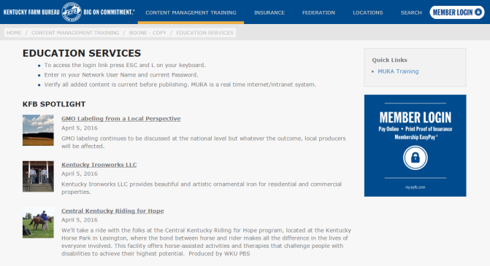 | Use IMG: SiteManagerSelected.png with a crop to just show top two search items. Add an arrow to point out globe icon.  Add action to globe icon to show IMG: ReviewPage.png
9 | To update content on an existing webpage, search for the page that needs updating.  Click on the pencil icon across from the page located on Site Manager.  If there is already a draft of an item, a Notice message will pop up, with the options: Edit Current Published or Edit Latest Draft.  Edit Current Published – will update the LIVE data on the internet or intranet.  Edit Latest Draft – will update content without updating the LIVE data, this allows you to work with content and return at a later time before publishing.  Edit the changes on the content page. Once changes are made select save draft or publish. | Use IMG: SiteManagerSelected.png with a crop to just show top two search items. Add an arrow to point out PENCIL icon.  Add action to pencil icon to show IMG: Notice.png

