SCORM Driver for Cross Domain
SCORM really likes for content and the player to reside in the same domain. Why? Basically, SCORM requires that content be served from the same domain as the LMS API. Browsers intentionally prevent the JavaScript in the content from communicating with the SCORM API if they originate from different domains. For content providers, this can be problematic for lots of reasons — maybe your content is database driven or the user experience is just better on your server.
In order for scorm courses to be hosted elsewhere you need to have a SCORM API wrapper that will pass the proper parameters to and from the LMS system.
Rustici Software offers a SCORM cross domain wrapper on their web site…
http://scorm.com/scorm-solved/scorm-driver/scorm-driver-cross-domain/
There are several free SCORM API wrappers available for download.
At Trivantis we use a scorm API that was initially provided by Mind Leaders. Here are screen shots of the files included…….
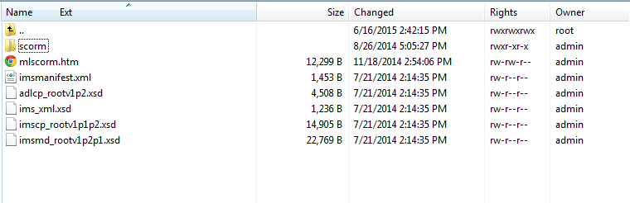

SCORM folder….
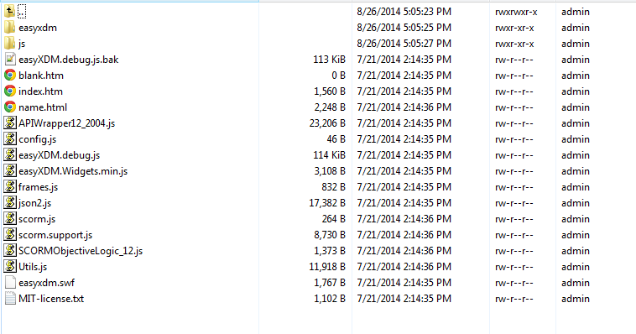

CourseMill Course Launching
In the course set up for CourseMill there is a starting directory where the courses reside. This is basically the starting point…
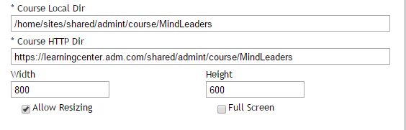

In the content settings for courses there is a launch URL. This is an example of how the SCORM wrapper API is called, and set to launch the course….
scorm/index.htm?url=lmsdata.s3.amazonaws.com/_fetcher/provider.htm&sco=../../Skin003Trivantis/20508/engine/Version_1_4_6/Launch_SCORM.html
index.htm inside the scorm folder runs the .js files necessary to run a course remotely, and pass all parameters between CourseMill, and the course.

