Well today the first time I want to utilize the eLearning Brothers content so I launch my Lectora Inspire v12.1.0.

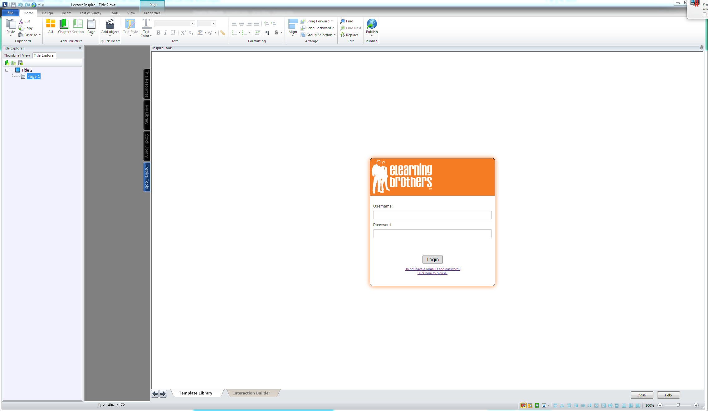

Wait I need a user Name and Password? I don’t remember this… I thought this was integrated?

Not a problem I’ll just click the “Do not have a login ID and password?” link

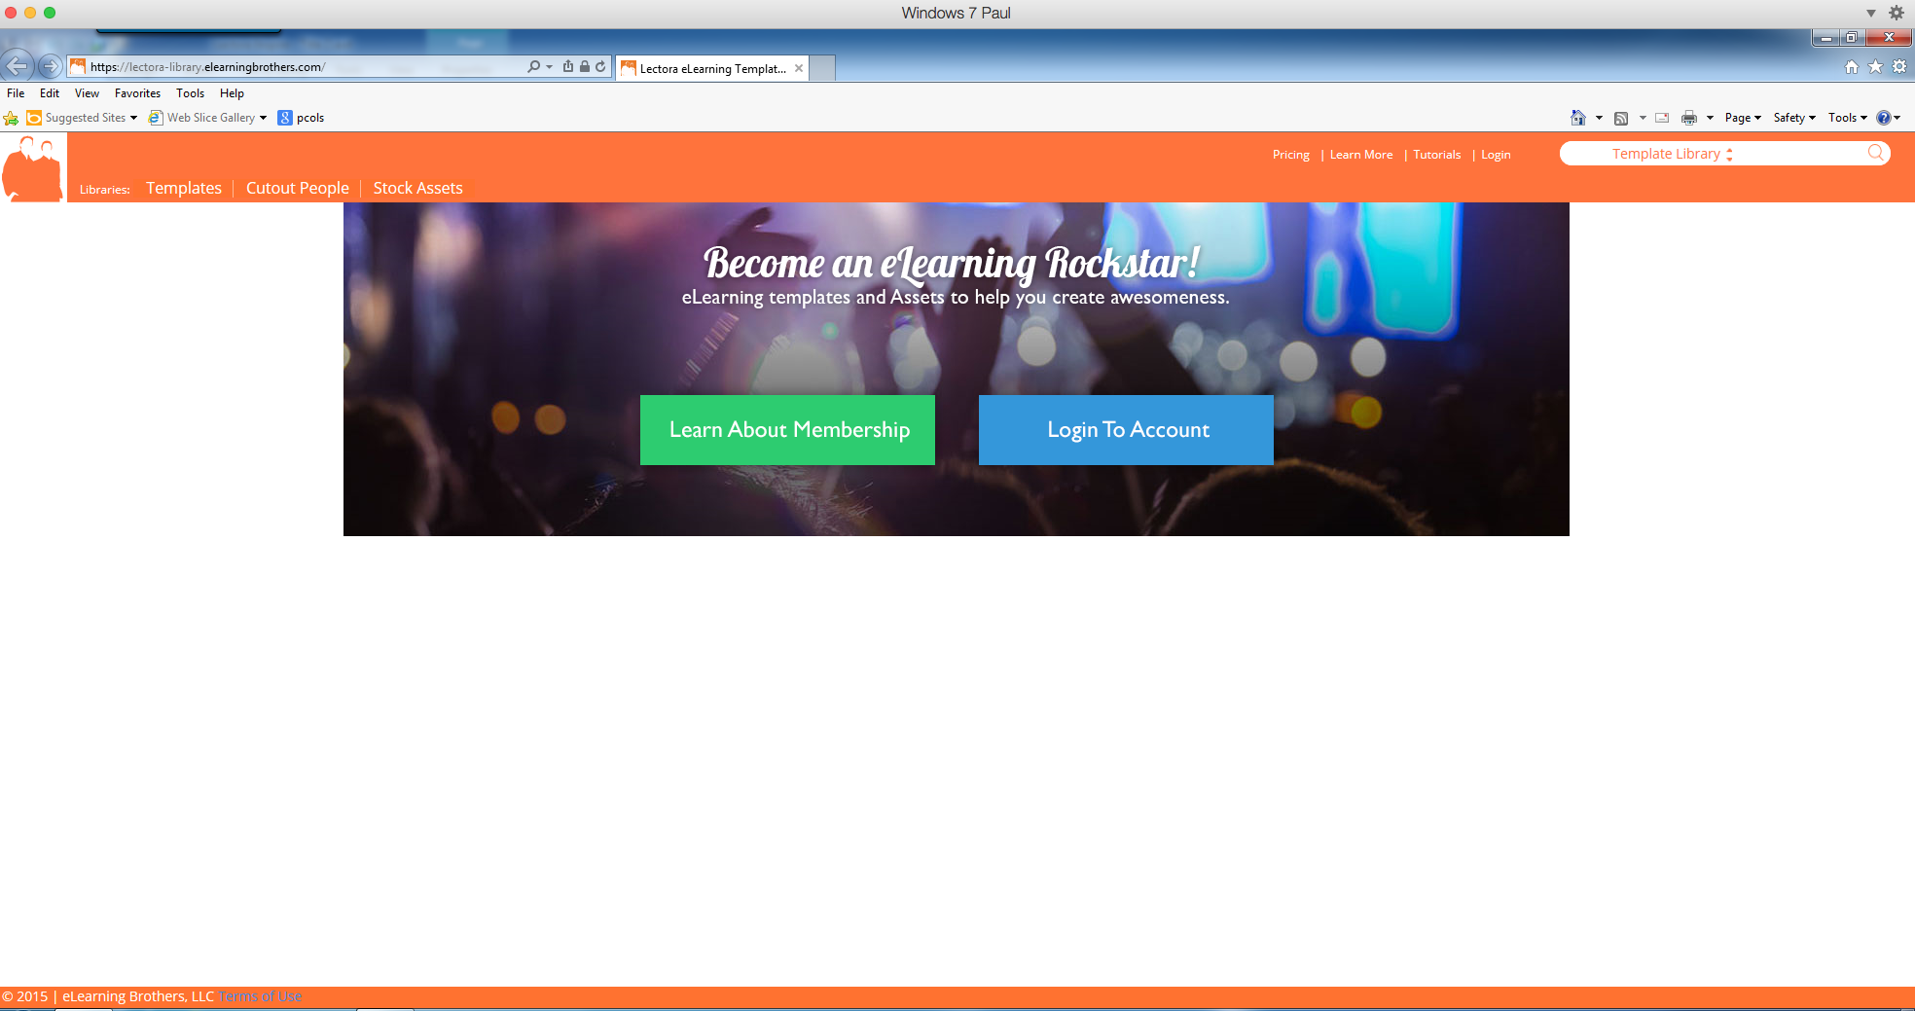
Well look at hat a website that says learn more or Login to account… Well I guess I want to learn more? Yes/no not sure but can’t login to an account I don’t have… So I’ll click the Learn more button..

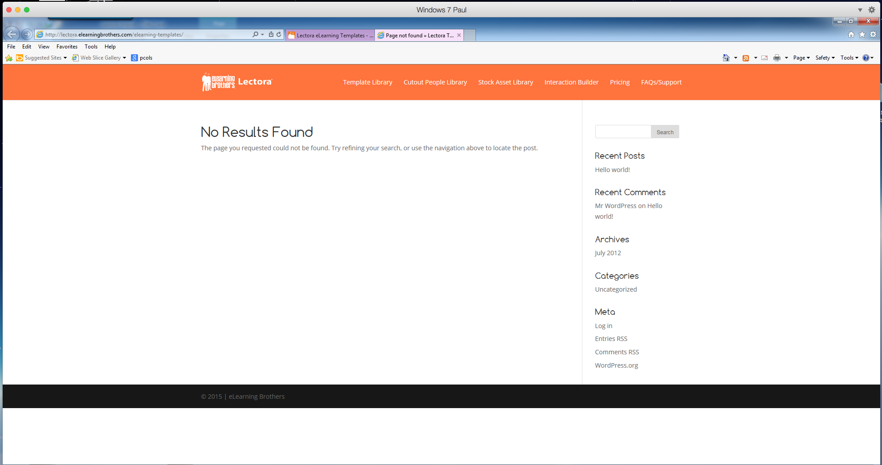

Wow I guess that I can’t learn more. Lets go back and try to login.

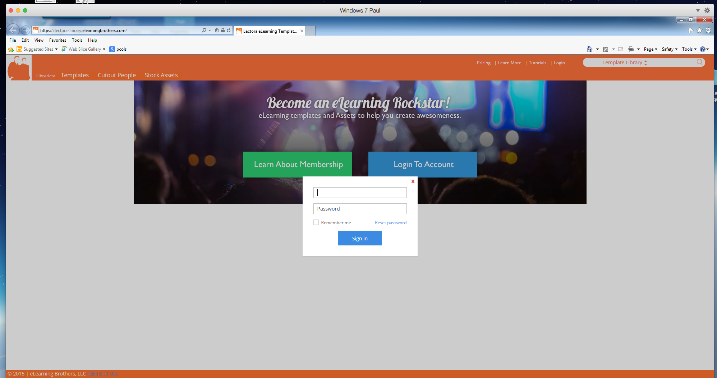

Uhmmm dang wants a user name and password just like Lectora. :-/

I guess Ill try clicking the links at top “learn more” here we come… I hope.

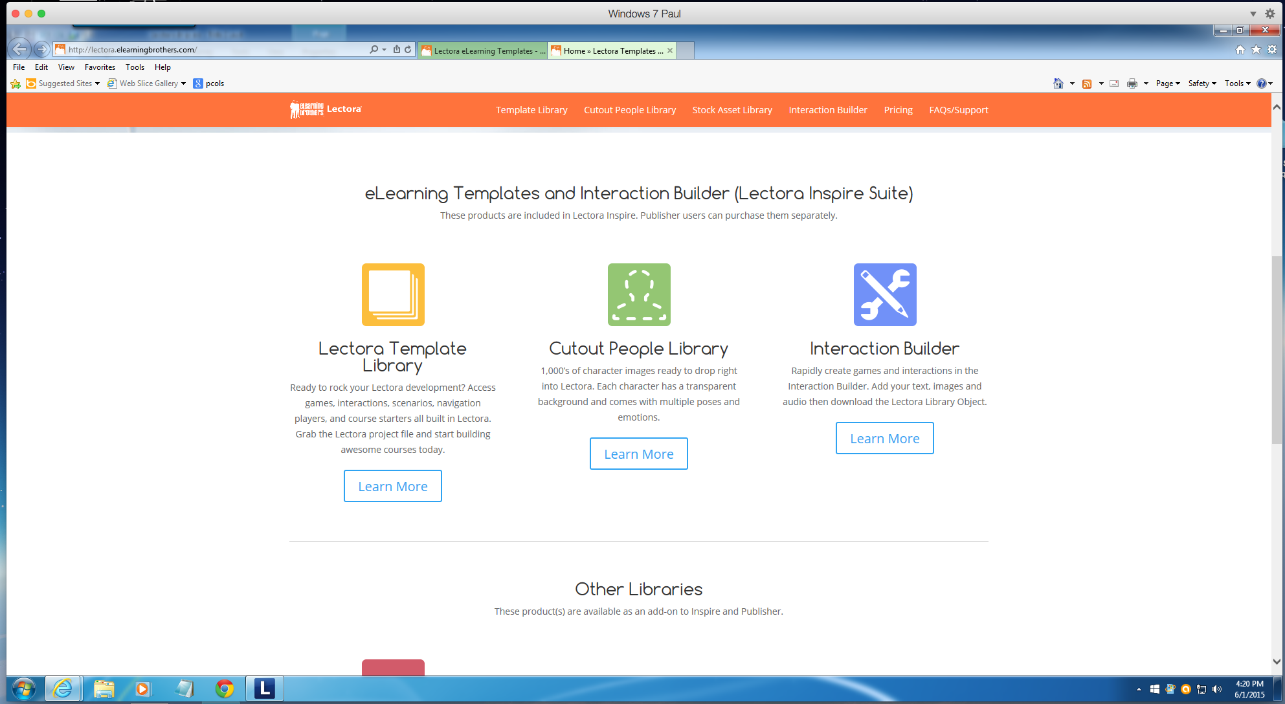

Hey look at that it worked… and it also says that “These products are included in Lectora Inspire” . I guess I’m still missing something here.

I click the Learn More button under cutout people Library to see what I get.

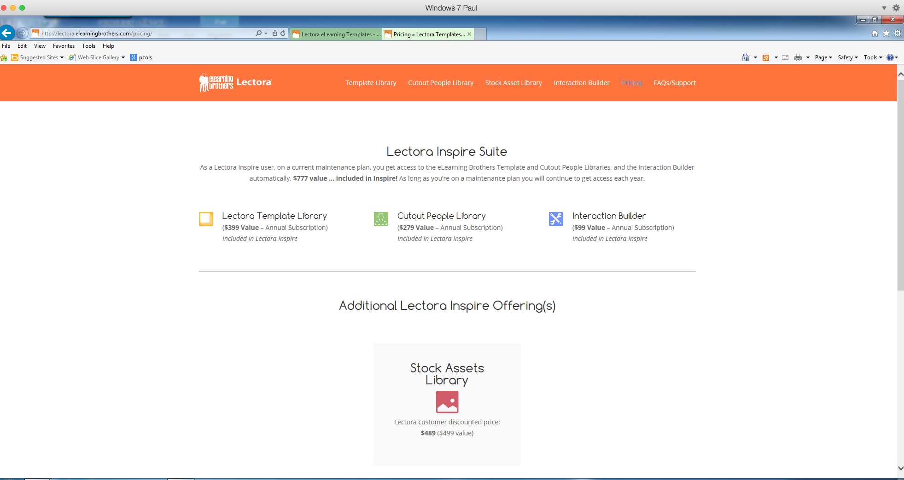

Really… this is now getting annoying.

Change tactics…. I’ll click the FAQ for more help.

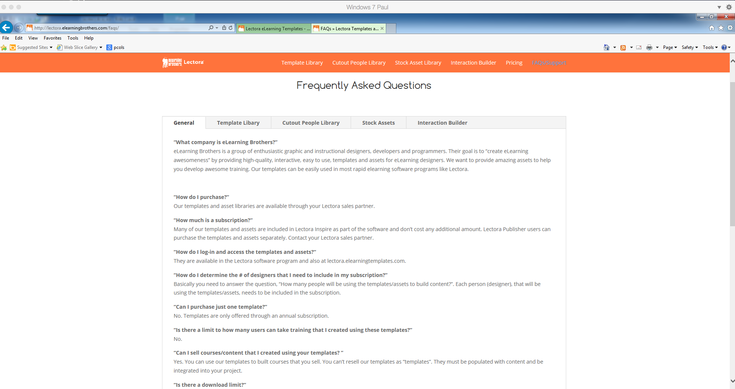

This is a joke right the FAQ is ““How do I log-in and access the templates and assets?“

And the answer is “They are available in the Lectora software program and also at lectora.elearningtemplates.com.”

That did not tell me how to LOGIN!!!!! Wait did anyone notice that they went from LOGIN to LOG-IN?

Ok ok lets go back to Lectora Inspire and try this in another way.

I’ll check out the Help section… do a quick search for brother and yeah things pop up.

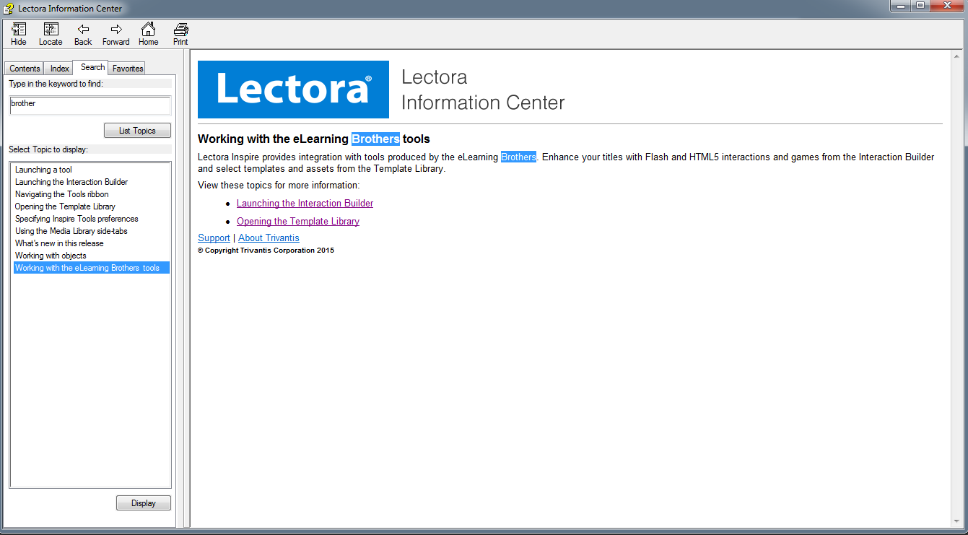

I click “Opening the Template Libry” and get

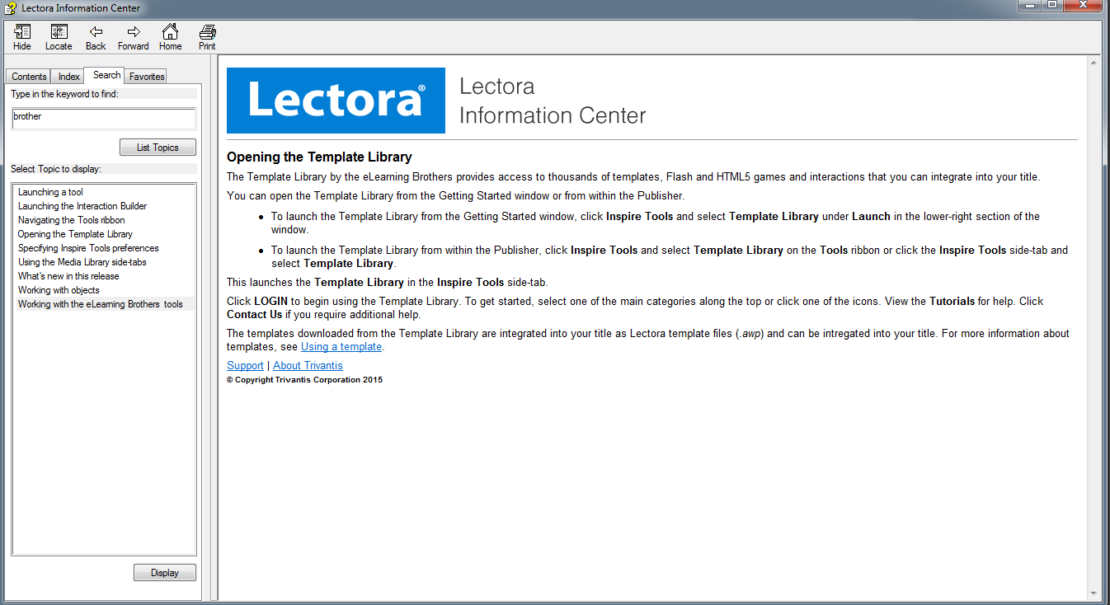

WHAT…. Just click LOGIN… REALLY??

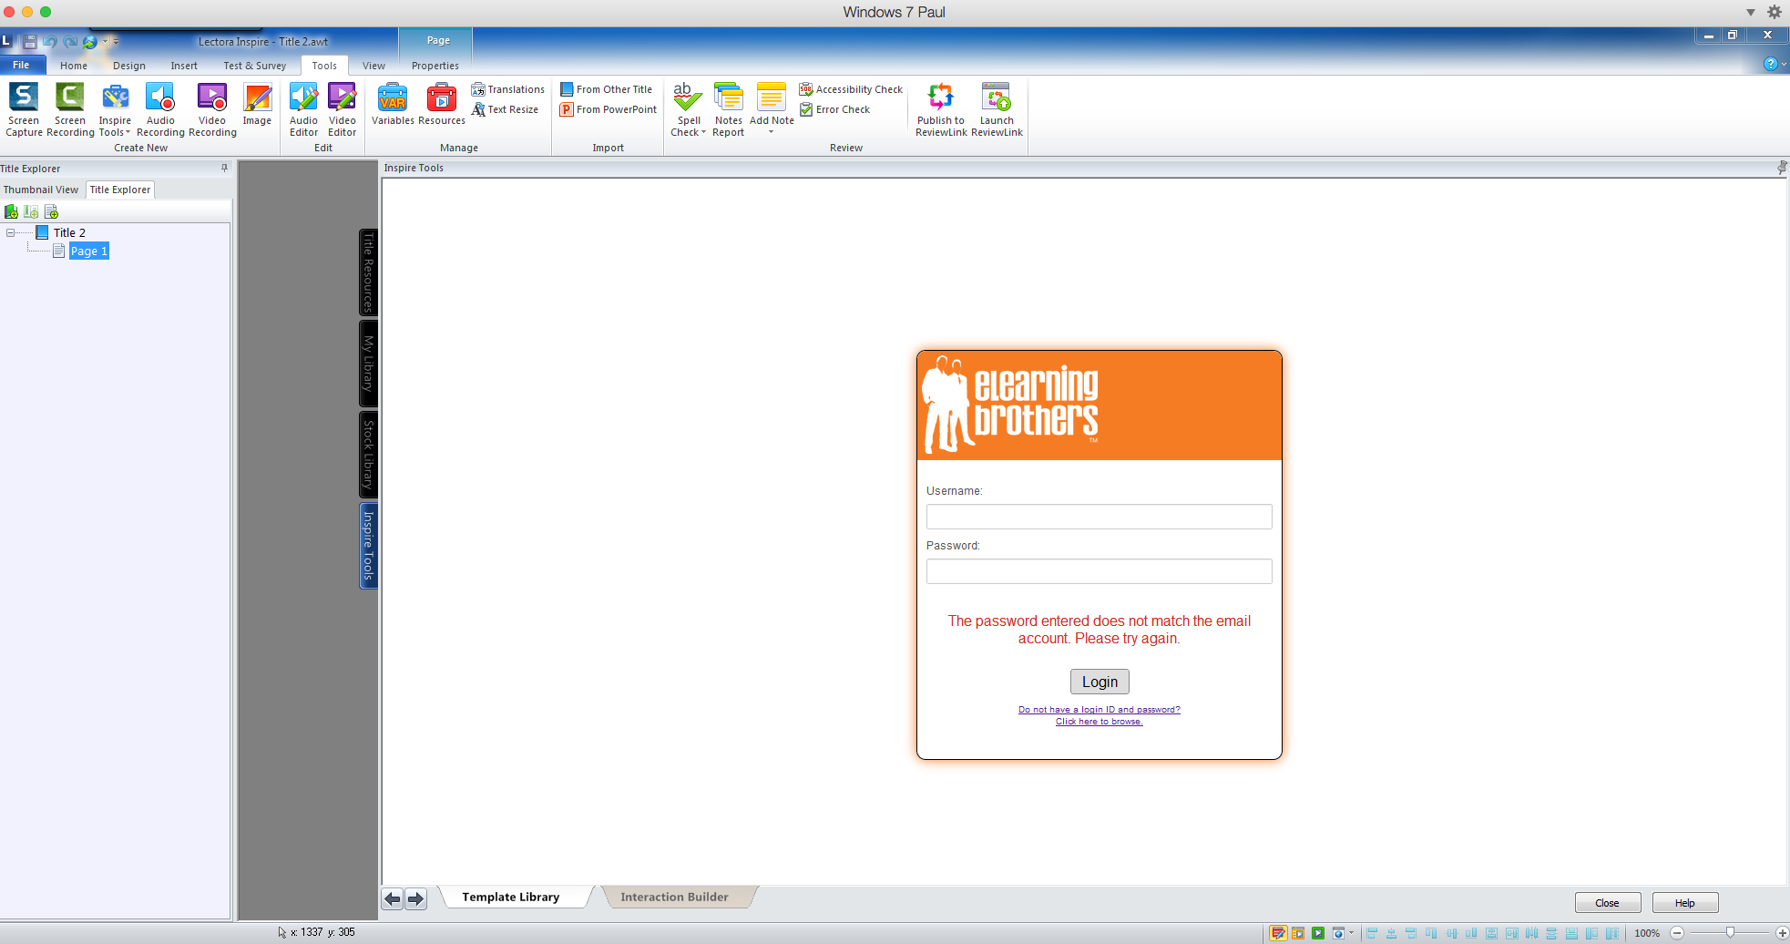

That did not work…..

Guess I use the contact us option for more help
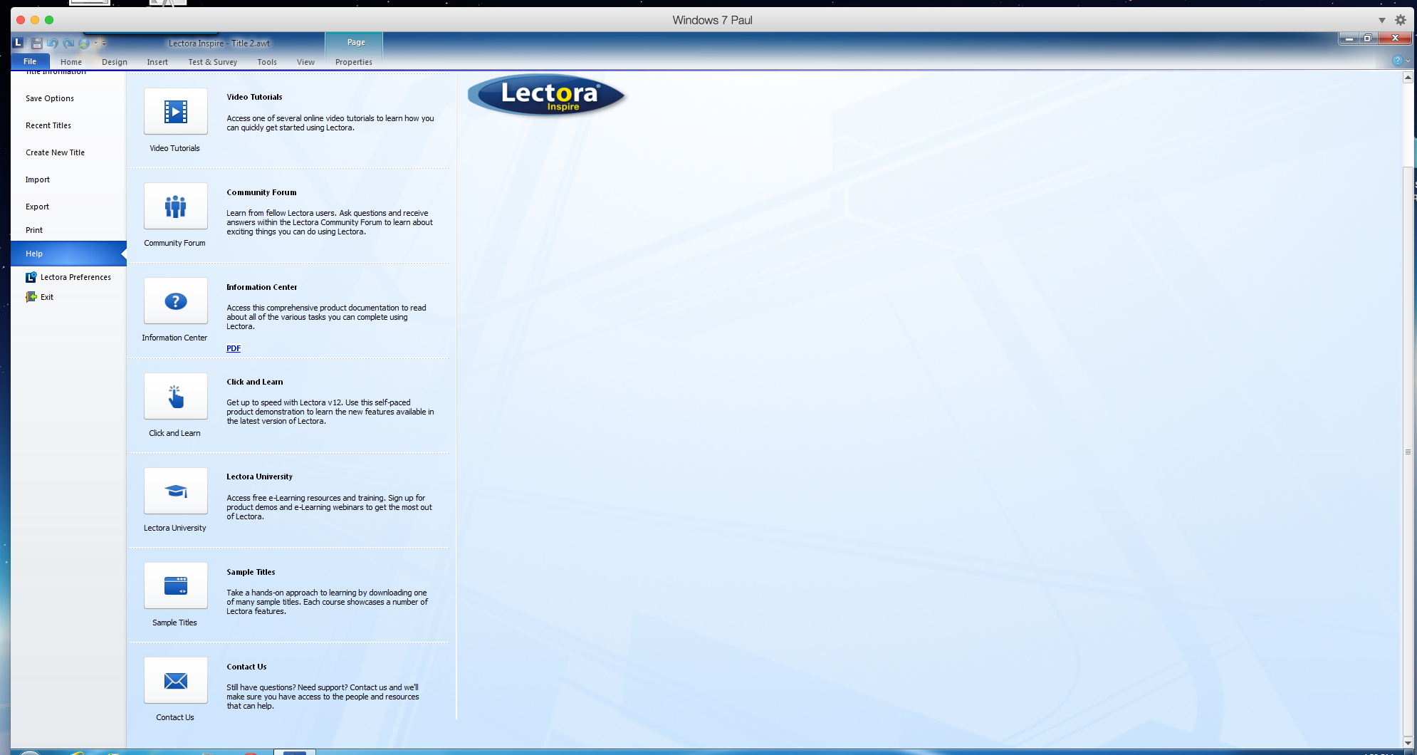

clicking the contact us button and…

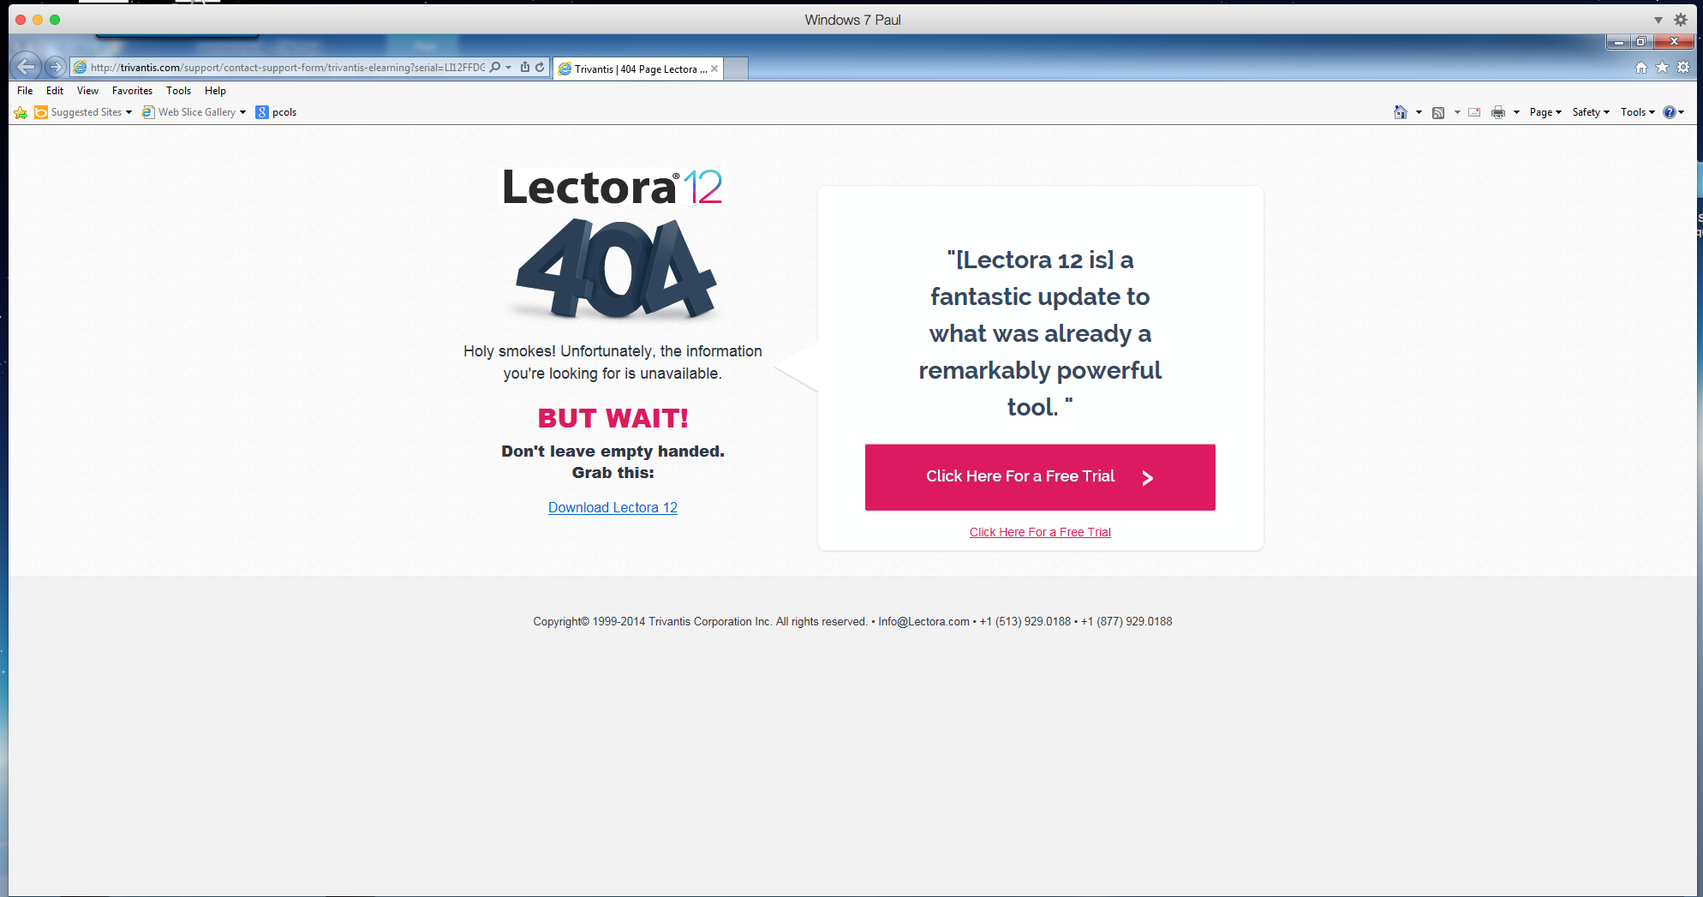

You got to be kidding….. what in the world is this??

